CONTACT: Lisa Neher, lisanehermusic@gmail.com

FOR IMMEDIATE RELEASE:
Cascadia Composers presents an intimate house concert with wine and appetizers:
Cycles of Life
Saturday, February 10th at 7 pm and Sunday February 11 at 3 pm, 2024
An intimate house concert with wine and appetizers!
Home of Linda and Connelly Woody
West Linn, OR

Cycles of Life is a concert of music for voice and piano, together and in solos, exploring the experiences and emotions we encounter as we navigate the path of life. The music is lyrical, dramatic, funny, and poignant, with works exploring the sleepless excitement of your first crush and the night before your wedding, the loneliness of losing a loved one or moving away from home, the joy of feeling at home in your body, the search for gratitude in the face of struggle, the loving protection of parents for their children during a time of climate crisis, and more.

Cycles of Life is a unique concert. The performers Dianne Davies, piano, and Lisa Neher, mezzo-soprano, are also the composers of the music you will hear. They bring their perspectives as composer-performers and their lens as women creators to this program. Soprano Lindsey Rae Johnson joins them for several vocal duets and Kaleb Davies joins on percussion. Experience Cycles of Life in an intimate house concert venue in West Linn, Oregon, while enjoying appetizers and wine, and get to know the artists after the concert. Hosted by Linda and Connelly Woody.

Tickets are $30 for general admission, $20 for Cascadia Members and seniors, and $15 for students. Tickets are available through Ticketleap at https://lisaneher.ticketleap.com/cycles-of-life/ and include wine (for audience members 21 years and up) and appetizers.

We hope you can share in this exciting concert of new music from Cascadia Composers members! For more information go to https://www.cascadiacomposers.org/upcoming/cycles-of-life

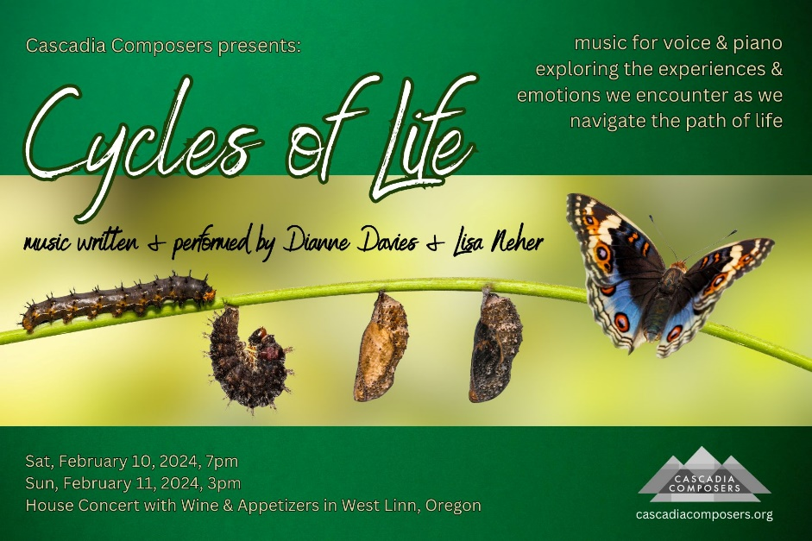
About the Artists

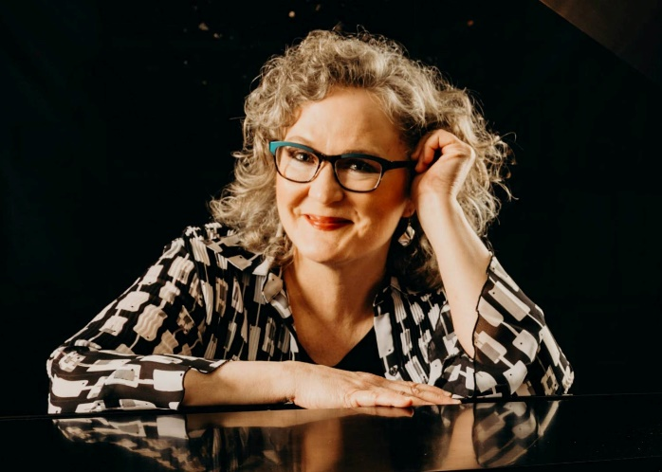 | 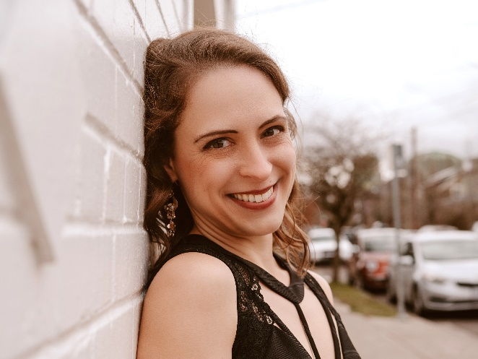
Dianne Davies | Lisa Neher
Dianne’s multi-faceted career includes composing, arranging, and performing. Her finely crafted piano music is centered on the natural world of creation or sonic representations of her life experiences. Her arrangements are an amalgam of her two greatest loves of music: traditional gems of sacred music and the works of major composers from a classically trained pianist’s repertoire. Her shows span from deeply personal to slap stick comedy that combine piano music with dance, live visual art creation, and theatre. For her upcoming projects, check out Dianne and her music at www.musiqPOWER.com. | With a voice praised as “full and rich” and “especially alive” (OR ArtsWatch), Dr. Lisa Neher’s performance credits include Third Angle New Music, Experiments in Opera, Renegade Opera, and the Portland Opera Chorus. Described as a “supremely talented,” “visionary composer” (Willamette Week), and author of “liquid, impressionist piano writing and fluent melding” of voices (New York Classical Review), Neher’s compositions are inspired by the climate crisis, the tender love of family and friends, and the eerie mystery of deep ocean life. Her works have been commissioned and performed by NATS, Cincinnati Song Initiative and Third Angle New Music, among others. www.lisanehermusic.com

Cascadia’s Upcoming Events

Blackout 24/24, Saturday February 24th, 2024, 7:30 pm, Alberta House, 5131 NE 23rd Ave, Portland, OR—New music in the dark, where the perception of music and our imagination intertwine. Total darkness – except for occasional theatrical lighting – is our sound architect. Works by Cascadia’s Daniel Brugh, Nick Yandell, and others.

May the Fourth be With You!, Saturday May 4th, at 7:30 pm, Lincoln Recital Hall, 1620 SW Park Ave, Portland, OR—Exciting new music by the Jedi composers of Cascadia, performed by the Chameleon Winds quintet and outstanding pianists.

In Good Hands 2024, Saturday July 20th, at 4 pm, Lincoln Recital Hall, 1620 SW Park Ave, Portland, OR—Talented young Oregon students perform new music of Cascadia Composers in this 13th annual celebration, including works written in collaboration with individual students by our composer members. Admission is free.

Featuring "the city’s most accomplished composers and most promising next-gen voices"
Willamette Week, April 2019

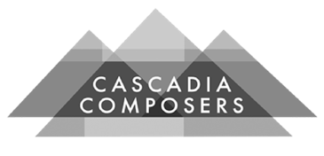

Cascadia’s Mission Statement

We engage our community through the creation, performance, and promotion of contemporary musical art, while providing resources and opportunities to composers connected to the Pacific Northwest.

Cascadia Composers is a local affiliate of National Association of Composers USA. It offers its members educational enrichment and presentation opportunities through monthly meetings. Members work in virtually every musical genre: chamber music, jazz, choral music, musical theater, electronic and electro-acoustic music, world music and orchestral music. Cascadia Composers’ members include independent professionals, composer/educators and students. Fostering a rich collaboration with local musicians, members share the benefit of being part of a regional community of composers who share common goals and aspirations.
###

Cascadia Composers upholds and embraces principles of inclusivity and equity in all our programming, for all our members and the community, in terms of gender, race, age, location, national origin, sexual orientation, religion, socio-economic status and artistic practice.

“Cascadia Composers is one of the state’s most valuable artistic entities.”
Brett Campbell, Oregon ArtsWatch

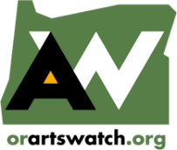
Cascadia Composers’ Media Sponsor

